What is Image Segmentation?
Image Segmentation is a computer vision technique that divides an image into meaningful segments (groups of pixels) to simplify analysis. Instead of analyzing an entire image at once, segmentation focuses on specific regions—like separating objects from the background.
The goal is to assign a label to each pixel so that pixels with the same label share certain visual characteristics (like color or texture). This enables precise object localization and identification.
Approaches to Image Segmentation
- Traditional methods: Use pixel features (e.g., color, intensity) and heuristics to detect edges and boundaries.
- Machine Learning & Deep Learning: Learn patterns from annotated data to segment objects more accurately using models like U-Net, FCN, and DeepLab
1. Difference between Image Classification vs. Image Segmentation vs. Object Detection

1. Image Classification
- Definition: Assigns a single label to the entire image.
- Example: A model identifies whether an image contains a car or a truck.
- Limitation: Cannot locate or distinguish between multiple objects in the image.

2. Object Detection
- Definition: Identifies what objects are present and where they are located using bounding boxes.
- Example: Detects multiple vehicles in an image and draws boxes around each.
- Limitation: Bounding boxes provide approximate location, not precise boundaries.

3. Image Segmentation

. Types of Semantic Classes
- Things: Countable, shape-defined objects like cars, trees, and people.
- Stuff: Amorphous, non-countable regions like sky, grass, water

a. Semantic Segmentation
- Definition: Assigns a class label to every pixel (e.g., road, car, sky), but does not differentiate between object instances.
- Semantic segmentation treats all pixels as stuff; it does not differentiate between stuff and things
- Limitation: Cannot distinguish between multiple instances of the same class.

b. Instance Segmentation
- Definition: Combines object detection with segmentation by labeling each object instance at the pixel level.
- Instance segmentation isolates things from stuff.
- Example: Identifies and segments each individual car separately, even if overlapping.
- Implementation: Two-stage (e.g., R-CNN) or one-shot (e.g., YOLOv4 with segmentation head).
- One-shot approaches offer greater speed (with a tradeoff in accuracy), whereas two-stage approaches offer greater accuracy (with a tradeoff in speed).
- Instance segmentation models must be able to separate and determine the shape of each one, whereas semantic segmentation models can simply lump them together

c. Panoptic Segmentation
- Definition: Merges semantic + instance segmentation by assigning each pixel both a semantic label and an instance ID.
- Purpose: Holistic scene understanding—“what” and “how many”.
- Challenge: Computationally expensive and difficult to balance both tasks.
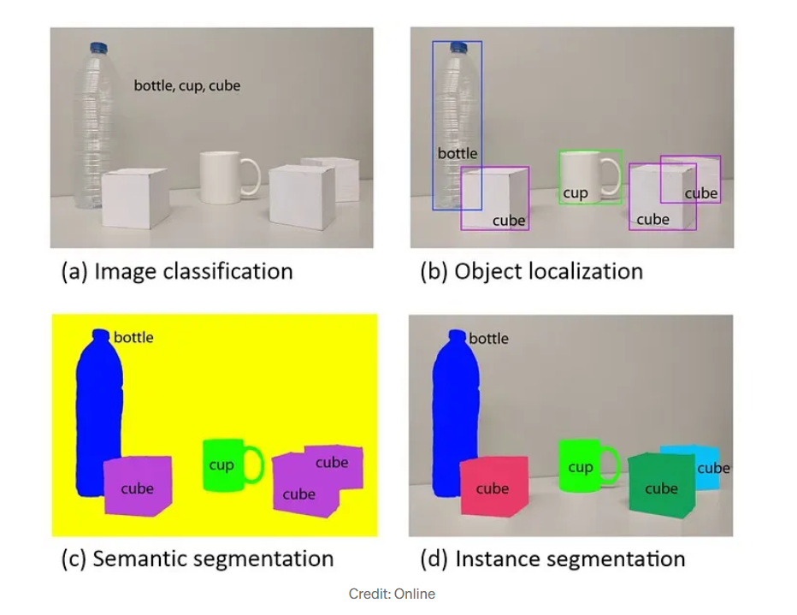

4. Traditional Image Segmentation Techniques

These use heuristics like pixel intensity, color, contrast:

Thresholding (e.g., Otsu’s method)

Edge Detection (e.g., Canny)

Watershed Transform - transform images into grayscale, then generate a topographical map(3D interpretation of a grayscale image) in which each pixel’s “elevation” is determined by its brightness.

Region Growing - group together neighboring pixels with similar characteristics.

Clustering (e.g., K-means)

5.Deep Learning for Segmentation
- FCNs (Fully Convolutional Networks): Base architecture for semantic segmentation.
- U-Net: FCN with skip connections to improve resolution—popular in medical imaging.
- DeepLab: Uses atrous convolution for larger receptive fields.
- Mask R-CNN: Instance segmentation using region proposals + FCN.
- Vision Transformers (ViTs): Use attention instead of convolutions for image features

6. What is U-Net?

U-Net is a convolutional neural network architecture that was originally developed for biomedical image segmentation. It is particularly good when you have limited training data and still want high segmentation

6.1 Architecture of U-Net

6.1.1 Encoder Path (Contracting Path)

Applies a series of convolutional operations followed by pooling to compress spatial information while retaining relevant features.

Structure:

3×3 convolutions with zero-padding

ReLU activations

2×2 max-pooling

Outcome: Produces a compact representation of the input image by capturing contextual features.

5.1.2 Decoder Path (Expanding Path)

Performs upsampling to gradually restore the original image size.

Structure:

Transposed convolutions (deconvolutions) - upsampling layers to increase resolution

Concatenation with corresponding encoder layer (via skip connections)

3×3 convolutions + ReLU to refine features
Function: Helps to recover spatial details and localize the features in the image.

5.1.3 Skip Connections

Definition: Directly link encoder feature maps to decoder layers at corresponding spatial levels.

Purpose:

Restore spatial detail lost during downsampling.

Enhance localization accuracy by combining high-resolution features from encoder with semantic features from decoder.

Implementation: Feature maps are concatenated across the channel dimension.

5.1.4 Final Layer

A 1×1 convolution maps each feature vector to the desired number of classes.

Sigmoid (binary) or softmax (multi-class) activation for pixel-wise classification.
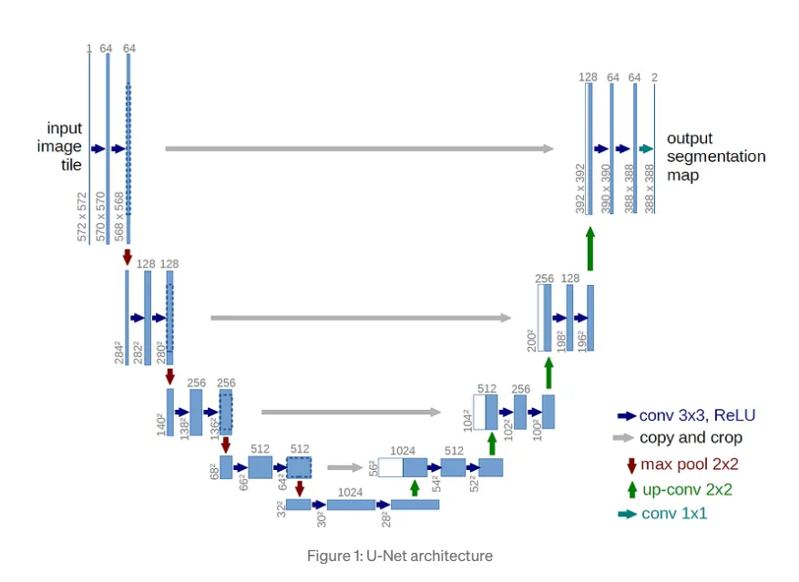

Relation Between Input and Output Size

The output of an image segmentation model usually has the same height and width as the input image.

This is necessary because segmentation assigns labels at the pixel level.

Encoder layers reduce spatial size; decoder layers use upsampling (e.g., transposed convolutions) to restore the original dimensions.

Cropping or padding may be used to ensure exact size match.

Segmentation Masks

Definition: Label maps that assign a class or instance ID to each pixel.

Types:

Binary Masks: 0 (background) or 1 (object)

Multi-class Masks: Integer values for each class

Instance Masks: Unique IDs per object instance

Used as ground truth during training.

Output of the model is compared against ground truth using loss functions like Dice Loss or Cross-Entropy.

Helps visualize segmentation results and assess accuracy.

Difference Between DICE Score and IOU Score

DICE Score and IOU Score are both evaluation metrics for image segmentation.

DICE Score (F1 Score) measures overlap between predicted and ground truth masks using the formula:
DICE = 2 × |A ∩ B| / (|A| + |B|)
It is more sensitive to small objects and useful in applications like medical imaging.

IOU Score (Jaccard Index) calculates the intersection over union of predicted and actual masks. It is stricter, penalizing both false positives and false negatives equally.

Key Differences:

DICE gives more importance to correctly predicted pixels and is more forgiving of small mismatches.

IOU is more conservative, requiring a higher level of agreement between the prediction and the ground truth.

Loss Functions and Evaluation Metrics for Image Segmentation

In image segmentation tasks, choosing the right loss function and evaluation metric is crucial for accurate and robust model performance, especially when the dataset is imbalanced.

Common Loss Functions:

Binary Cross-Entropy (BCE): Used for binary segmentation (e.g., foreground vs. background). It compares each predicted pixel value with the actual binary label.

Categorical Cross-Entropy: Used for multi-class segmentation where each pixel belongs to one of many possible classes.

DICE Loss: Computed as 1 minus the DICE score. It is especially useful for imbalanced datasets where some classes (e.g., tumors) appear very infrequently.

IOU Loss: Computed as 1 minus the IOU score. It focuses on improving the overall overlap of predicted and ground truth regions.

Focal Loss: Introduces a modulating factor to down-weight easy examples and focus training on hard examples. Useful for class imbalance.

Combined Losses (e.g., BCE + DICE): Often, combining BCE with DICE Loss leads to more stable and accurate training outcomes, especially in medical or small-object segmentation.

Common Evaluation Metrics:

Pixel Accuracy: Measures the percentage of correctly classified pixels. It can be misleading if the background dominates the image.

Mean IOU (mIOU): Computes the average IOU across all classes. It is a robust metric for multi-class segmentation.

DICE Score: Measures overlap between predicted and ground truth masks. High DICE indicates good segmentation quality.

Precision and Recall: Precision measures how many predicted positives are true positives. Recall measures how many actual positives were correctly predicted.

F1 Score: Harmonic mean of precision and recall; equivalent to the DICE score in segmentation.

